Lazomis QI — Audit Report

Sepsis Six Audit
Demonstration Data — fictional, not for clinical use

Audit standard
UK Sepsis Trust Sepsis Six care bundle; NICE NG51 (Sepsis: recognition, diagnosis and early management).

Background
The Sepsis Six is a set of six interventions that, when delivered promptly, improve outcomes in sepsis. This audit reviews compliance against each element to identify where care can be improved.

Aim
Measure delivery of all six elements of the Sepsis Six bundle within one hour of identifying sepsis.

Methodology
A retrospective case-note review was undertaken against the audit standard. Cases meeting the inclusion criteria were assessed for each criterion (Yes / No / Not applicable). Compliance was calculated as the proportion of applicable cases meeting each criterion, against a 95% standard. A total of 16 cases were reviewed, of which 15 met the inclusion criteria.

Inclusion criteria
- Adult patients (16+) with a clinical diagnosis of sepsis or suspected sepsis
- Patients triggering a sepsis screening tool / NEWS2 escalation

Exclusion criteria
- Patients on an end-of-life / palliative pathway where the bundle is not appropriate
- Paediatric patients (covered by a separate pathway)

Results
Cases reviewed: 16. Cases included: 15. Fully compliant cases: 8/15. Overall bundle compliance (all elements met): 53%.
Table 1. Compliance by audit criterion
Audit criterion | Compliance
Oxygen given to maintain target saturations | 100%
Blood cultures taken before antibiotics | 93%
IV antibiotics administered within 1 hour | 80%
IV fluid resuscitation commenced where indicated | 93%
Serum lactate measured | 100%
Urine output measured / monitored | 69%

Charts
Figure 1. Compliance by audit criterion (%)
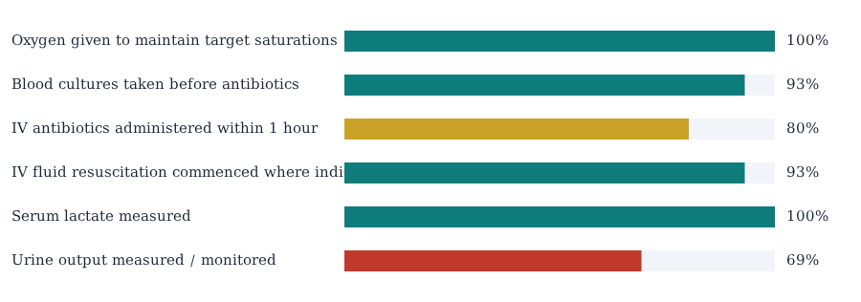

Interpretation
Compliance is below the expected target. Prioritise the lowest-performing elements and undertake a structured PDSA improvement cycle.

Recommendations
- Improve "Urine output measured / monitored" (currently 69%) towards the 95% standard through targeted education, prompts and process change.
- Improve "IV antibiotics administered within 1 hour" (currently 80%) towards the 95% standard through targeted education, prompts and process change.
- Improve "Blood cultures taken before antibiotics" (currently 93%) towards the 95% standard through targeted education, prompts and process change.
- Improve "IV fluid resuscitation commenced where indicated" (currently 93%) towards the 95% standard through targeted education, prompts and process change.
- Share results with the clinical team and embed changes into local induction and governance processes.

Action plan
Issue | Action | Lead | Timeframe
Urine output measured / monitored (69%) | Targeted education, process prompts and feedback to clinical team | Audit lead / ward team | Within 3 months
IV antibiotics administered within 1 hour (80%) | Targeted education, process prompts and feedback to clinical team | Audit lead / ward team | Within 3 months
Blood cultures taken before antibiotics (93%) | Targeted education, process prompts and feedback to clinical team | Audit lead / ward team | Within 3 months
IV fluid resuscitation commenced where indicated (93%) | Targeted education, process prompts and feedback to clinical team | Audit lead / ward team | Within 3 months

Re-audit plan
Re-audit is recommended within 6–12 months following implementation of the action plan to assess the impact of changes and confirm that improvements have been sustained. The same standard, criteria and methodology should be used to allow direct comparison.

References
- UK Sepsis Trust Sepsis Six care bundle
- NICE NG51 (Sepsis: recognition, diagnosis and early management).
Generated by Lazomis QI

